**CPNM Lab Assignment Day 3**

Date – 14-12-2022 (A2) 15-12-2022 (A3)

1. Write a menu driven C program that prints the following patterns for the input of ‘n’=4. The value of ‘n’ is input by the user. Do for **any 4** patterns.

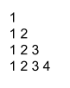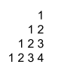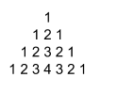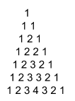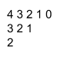

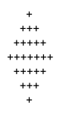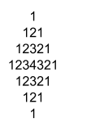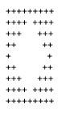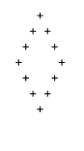

**Show for n = 5 and n = 8.**

1. Write a menu driven C program to find out Armstrong numbers (of any number of digits) within a range specified by the user. **Must** create a function called “isArmstrong” which takes a number as input and returns true (1) if the number is Armstrong number, else returns false (0). The program should keep asking for range until the user enters 0 & 0 (stopping criteria). You can reuse code from previous assignment.
2. Write a menu driven C program to create a calculator that takes two numbers from the user as input and any one of the following operands (+, -, *, /, %). Create functions for each of the operations that takes two numbers as arguments and returns the desired result. The program must ask for two numbers and an operand continuously until both numbers are input as 0 (zero). *You have to show the results of all operators in the output.*
3. Write a menu driven C program with recursive function to print factorial of a number given by the user. The program should keep asking the user for a number until the user inputs -1.
4. Write a menu driven C program with recursive function to print fibonacci series of first “n” numbers where “n” is given by the user. The program should keep asking the user for a number until the user inputs -1.
5. Write a menu driven C program to convert among binary, octal and decimal numbers. You can create only four functions *[Optional]*
   1. to convert a binary number to decimal
   2. to convert a decimal number to binary
   3. to convert an octal number to decimal
   4. to convert a decimal number to octal

Example-

Press 1 for binary to decimal

Press 2 for decimal to binary

Press 3 for octal to decimal

Press 4 for decimal to octal

Press 5 for binary to octal

Press 6 for octal to binary

5

Enter binary number: 1010101

Octal equivalent is: 125

Press 1 for binary to decimal

Press 2 for decimal to binary

Press 3 for octal to decimal

Press 4 for decimal to octal

Press 5 for binary to octal

Press 6 for octal to binary

6

Enter octal number: 15

Binary equivalent is: 01101

Press 1 for binary to decimal

Press 2 for decimal to binary

Press 3 for octal to decimal

Press 4 for decimal to octal

Press 5 for binary to octal

Press 6 for octal to binary

0

1. Write a function to compute the distance between two points and use it to develop another function that will compute the area of the triangle whose vertices are A(x1, y1), B(x2, y2), and C(x3, y3). Use these functions to develop a function which returns a value 1 if the point (x, y) lies inside the triangle ABC, otherwise a value 0. *[Optional]*
2. Write a menu driven C program to check whether a positive integer number not containing the digit 0 (zero) is a palindrome or not. Do not use arrays. Use proper error checking. Input 0 as the terminating condition. Example - *[Optional]*

Enter a number-

400

Number cannot contain 0

Enter a number-

-7687

Number cannot be negative

Enter a number-

1234

Not a palindrome

Enter a number-

123321

Palindrome

Enter a number-

0